APPLICATION FOR FREE AND REDUCED PRICE SCHOOL MEALS
2017-2018
Thank you in advance for returning this application as soon as possible. We’re looking forward to a great school year!!
Attached is an application for free and reduced price school meals. A new application must be submitted every year. Parents are encouraged to fill out the application if they think they might qualify… many people are surprised to discover that they fall within the income guide lines. All information reported is strictly confidential.
If your household is enrolled in the Food Assistance Program you should have received a letter from the school stating that no application is necessary for your child. Please make sure that all of your children are included in that letter, and if a student is missing, please call Jennifer Wing at 906-586-6631 as soon as possible. This is an issue that can be quickly resolved.
You should complete the application and return it on/or before the first day of school even if your child isn’t sure he/she will be eating lunch or breakfast as it can benefit the entire district. Each child will receive a letter indicating his/her meal status for the 2017-18 school year. Breakfast costs $1.00; lunch costs $2.50, the reduced price is $.30 for breakfast and $.40 for lunch. Please take the time to fill out the form, since a good breakfast and lunch are a very important part of each student’s day.
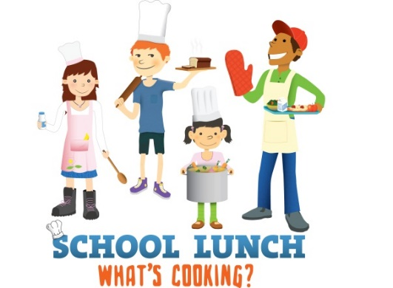
Applications may also be submitted online at threelakesacademy.com under the Students & Parents tab, choose food service. The application can be found there. The direct link for an online application is -https://mealmagic.eupschools.org/mealmagic/mylunchaccount/Default.aspx. If you have questions, or need assistance in completing the application, please stop by the Three Lakes Academy office or call Jennifer Wing at 586-6631.
**Note: If at any time during the school year a member of the family becomes unemployed or there is a decrease in income, you should immediately request a form by calling Jennifer Wing at 586-6631.

